TABLE OF CONTENTS
- Abstract
- Introduction
- Fall detection dataset
  - Description of the Dataset
  - Subjects and Activities
  - Ethical Approval and Consent to Participate
  - Sensors and Distribution
  - Hardware Implementation, Data Pre-Processing and Consolidation
  - Data Storage and Publishing
- Use Cases
- Existing Systems
5.1What’s new with our model
- Algorithm
- Problem Analysis
8.1. Feasibility Analysis
8.2. Project Plan
9. Software Requirement Analysis
10.Model Design
10.1.Data Flow Diagram
11.Testing
11.1Functional testing
11.2Structural testing
12.Source Code
13.Project Legacy
13.1Current Status of Project
14.Final Result

- Abstract:

Falls, particularly in older people, are a significant medical issue around the world. Dependable fall location frameworks can moderate negative results of falls. Among the significant difficulties and issues detailed in writing is the trouble of reasonable examination between fall discovery frameworks and AI methods for recognition. In this paper, we present UP-Fall Detection Dataset. The dataset involves crude and capabilities recovered from 17 sound youthful people with no disability that performed 11 exercises and falls, with three endeavors each. The dataset likewise abridges in excess of 850 GB of data from wearable sensors, surrounding sensors and vision gadgets. Two test use cases were appeared. The point of our dataset is to help human movement acknowledgment and AI investigate networks to reasonably look at their fall discovery arrangements. It additionally gives numerous test potential outcomes to the sign acknowledgment, vision, and AI people group.

- Introduction:

As indicated by the World Health Organization (WHO), falls are, all around, the subsequent driving reason for inadvertent damage and passing. Falls likewise much of the time cause useful conditions in older. "Around 28–35% of individuals matured of 65 and over fall every year expanding to 32–42% for those more than 70 years old". The rate of falls changes in various nations and is less regular in created nations. In Mexico, 33.5% of the older more than 60 years old endured in any event one fall in the year before the meeting.

Fall pervasiveness increments with age all around and is really viewed as a significant medical issue. Falls regularly require quick medicinal consideration since they lead to 20–30% of mellow to extreme wounds or even passing. Fall discovery frameworks ready when a fall happens moderating its results. Negative results of falls can be diminished with constant fall location improving the time required for the patient to get therapeutic consideration. Patients once in a while remain laying in the floor causing extra therapeutic and mental issues if falls are not recognized rapidly. When observing falls in subjects in genuine conditions at less-visit timeframes, members will in general overlook the precise information of a fall. This review issue is progressively basic especially in senior or disabled members. Fall identification frameworks can decide the ongoing of fall.

There are three fundamental methodologies revealed in writing for fall recognition frameworks relying upon whether information is procured with wearable sensors, encompassing sensors or vision gadgets. Igual et al. classified fall finders into two expansive approaches: setting mindful frameworks and wearable gadgets. Setting mindful frameworks consider all frameworks utilizing sensors conveyed in the earth, which incorporate encompassing sensors as infrared, floor, radar, mouthpieces, and weight sensors just as vision-based gadgets. Cameras, movement catch gadgets, and Kinect are considered additionally as setting mindful frameworks. Wearable sensors with accelerometers and spinners are much of the time utilized in fall finders. Recently, sensors installed in advanced mobile phones, savvy watches and other compact gadgets have picked up notoriety in fall discovery frameworks because of the incredible moderateness and worldwide reception of these gadgets. Different creators, for example, Mubashir et al,divided the methodologies for fall identification in three classifications: wearable gadget based, mood sensor-based, and vision-based. These audits of fall discovery frameworks and later studies like that in present point by point investigation of advantages and confinements of these methodologies, and extra novel multimodal frameworks which incorporate various mixes of wearable, vision and encompassing sensors. Among the significant difficulties and issues detailed by most creators are protection concerns, prominence and usable gadget restrictions, and trouble of examination among systems. This last issue is brought about by the absence of open databases, particularly those chronicle genuine falls of old.

Because of rarity and assorted variety of falls, all things considered, it is hard to gather datasets of real startling falls. Most datasets for fall recognition are reenacted in research center settings. Khan et al,described the issue of the colossal irregularity of genuine falls information: if all people in a nursery where to fall 2.6 occasions by and large in a year, the last dataset recorded in one year would have 31.55 million of typical exercises for each individual and 2.6 falls. Consequently, albeit mimicked fall information can't generally replicate a fall precisely, building datasets gathering information of volunteers that recreate various falls appears to be as yet the best choice for fall recognition framework assessment. Numerous overviews revealed that there is an absence of reference system and a couple freely accessible datasets for fall discovery can be found. These realities, notwithstanding no entrance to genuine information, prevent frameworks and strategy approval and examination.

We present an openly accessible multimodal dataset for fall identification so as to address the issue. The UP-Fall Detection dataset was gathered utilizing 17 sound youthful subjects with no weakness utilizing various modalities in particular wearable sensors, encompassing sensors and vision gadgets. The volunteers performed six every day living exercises and recreated five unique kinds of falls, with three endeavors each. We utilize five wearable sensors to gather accelerometer, gyrator and surrounding light information. Moreover, we procured information from one electroencephalograph (EEG) headset, six infrared sensors, and two cameras. This dataset contains crude and capabilities condensing in excess of 850 GB of data from wearable sensors, encompassing sensors and vision gadgets.

The point of our dataset is to help human movement acknowledgment and AI investigate networks to reasonably look at their fall recognition arrangements. It likewise gives numerous exploratory potential outcomes to the sign acknowledgment, vision, and AI people group. We know that as the falls were mimicked by youthful solid grown-ups without weakness for security reasons, a few contrasts can be found with genuine falls in old. By and by, this dataset can be utilized to move learning tests for expectation in old individuals or grown-ups with weaknesses.
- Fall Detection Dataset:

This region shows the UP-Fall Detection dataset and depicts the technique of its acquiring, pre-dealing with, joining and storaging. Besides, one potential part extraction process is moreover point by point.

3.1 Description of the Dataset:

We present a tremendous dataset generally for fall revelation, specifically UP-Fall Detection, that joins 11 activities and 3 fundamentals for each activity. Subjects performed six direct human step by step practices similarly as five remarkable sorts of human falls. These data were assembled in excess of 17 strong young adults without shortcoming using a multimodal approach, i.e., wearable sensors, incorporating sensors and vision contraptions. The consolidated dataset (812 GB), similarly as, the part dataset (171 GB) are openly available in

The data were accumulated over a period of about a month, from 18 June to 13 July 2018 in the third floor of the Faculty of Engineering, Universidad Panamericana, Mexico City, Mexico. All of the contraptions and rigging for estimations were related locally to a great deal of PCs. These PCs united every one of the information and saved the data in hard drives. The bits of knowledge concerning the dataset are following.

3.2. Subjects and Activities:

During the grouping of data, 17 energetic strong subjects with no shortcoming

(9 male and 8 female) stretching out from 18–24 years old, mean stature of 1.66 m

moreover, mean heap of 66.8 kg, were free to perform 11 one of a kind activities.

On the other hand, each ZIP-report contains a great deal of RGB pictures in PNG plan. These photos have a record name definitely as the timestamp when they were taken, so they can be associated adequately with the data from sensors. Figure 4 shows a great deal of pictures that are assembled in the dataset. It is fundamental to see that notwithstanding the way that the dataset was accumulated from falls reproduced by young sound subjects with no shortcoming, we melded non-fall practices and is outstandingly imbalanced as prescribed in order to imitate sporadic falls of authentic conditions.
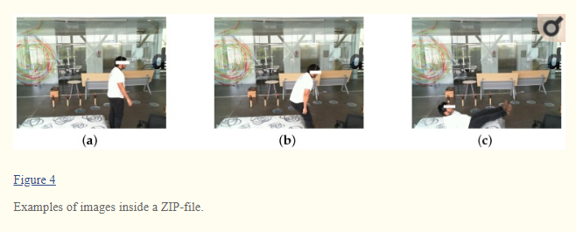
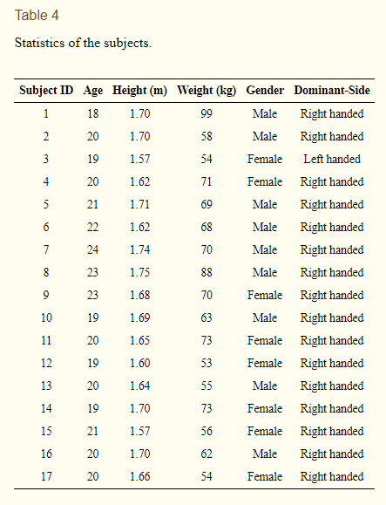
The activities performed are related to six fundamental human step by step works out (walking, standing, getting an article, sitting, jumping and laying) and five human falls (falling forward using hands, falling forward using knees, falling backward, falling sitting in an empty seat and falling sideward). These sorts of activities and falls were investigated the assessment of those declared recorded as a hard copy . Falls happens playing out a mind boggling variety of conditions and propensities . We endeavored to reenact states of falls when faltering, sitting and in different headings. We picked the most regularly ADL and explicitly, snatching a thing was fused given that it isn't sudden to mess up this activity with a fall. Each and every step by step development were performed during 60 s, beside jumping that was performed during 30 s and getting a thing which it is a movement done once inside a 10-s period. A single fall was performed in all of the three ten seconds time allotment fundamentals. Time windows for step by step practices were picked to cover them in at any rate the range time reported in near assessments .while window time for falls was picked reliant on the 6-s safe period after fall occasion, as uncovered in .For all of these activities, a resting pad was arranged in the falling domain to check wounds. Each development was played out various times (fundamentals) by each young strong subject with no incapacitation. Table 5 traces the activities and the length each primer takes in the last dataset.
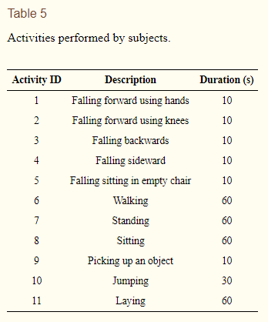

3.3. Ethical Approval and Consent to Participate:

The Research Committee of Engineering Faculty of Universidad Panamericana confirmed all the assessment philosophy. All stable energetic adults without shortcoming that looked into this assessment as of late balanced a simultaneousness with the main inspector and the Faculty of Engineering, considering the rules and data methodologies material. The decision to look into these assessments was intentional.

3.4. Sensors and Distribution:
In order to accumulate data from energetic sound subjects with no impedance, we consider a multimodal approach for recognizing the activities in three particular ways using wearables, setting careful sensors and cameras, all at the same time. We used a controlled research office room in which light power doesn't vary, and the setting careful and cameras remain also arranged during the data combination process. Regardless, we decided to keep up the windows indisputable, along these lines every so often there are narratives from cameras that show people moving far out.

We use five Ambiental MetaSensor wearable sensors gathering unrefined data from the 3-center point accelerometer, the 3-rotate whirligig and the encompassing light worth. These wearables were arranged in the left wrist, under the neck, at right pocket of pants, at the focal point of midriff (in the belt), and in the left lower leg. Furthermore, one electroencephalograph (EEG) NeuroSky MindWave headset was included to measure the rough brainwave signal from its stand-out EEG channel sensor arranged at the sanctuary. The sensor position has reliably been a test in fall recognizable proof and human activity affirmation. According to waist, thigh (pocket), wrist, chest, foot are the favored zones for accelerometers and accelerometers embedded in splendid devices. We chose to arrange one IMU in the left wrist repeating that the part is wearing a sharp. We put another IMU in the right pocket impersonating the spot for wearing a propelled cell. The sensor positions were picked considering a right-gave person. A transcendent versus non-winning side position assessment is out of the degree of this work. The transcendent side of the subjects is showed up in Table 4.

As setting careful sensors, we presented six infrared sensors as a system 0.40 m over the floor of the room, to check the alterations in impedance of the optical devices, where 0 infers obstruction and 1 no impedance. At last, two Microsoft LifeCam Cinema cameras were arranged at 1.82 m over the floor, one for a flat view and the other for a frontal view. Figure 1a shows the region of the wearables in the body and Figure 1b shows the structure of the setting careful sensors and cameras. A certified photography of the exploration focus with the devices is showed up in Figure 2. In like manner, Table 6 gathers all of the sensors in question and the units of estimation for each channel.
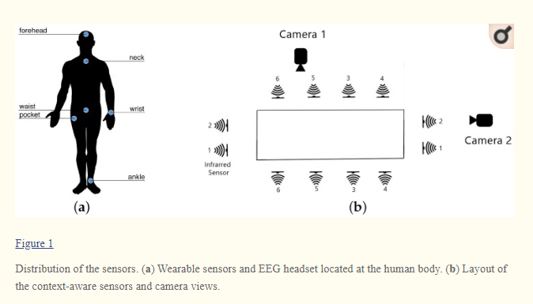
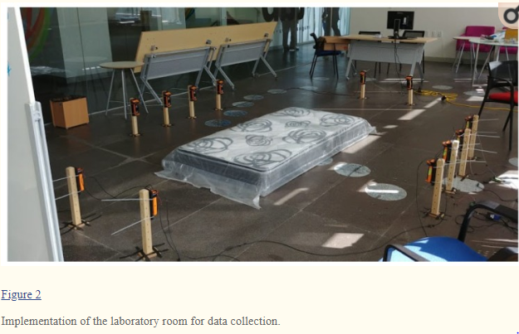
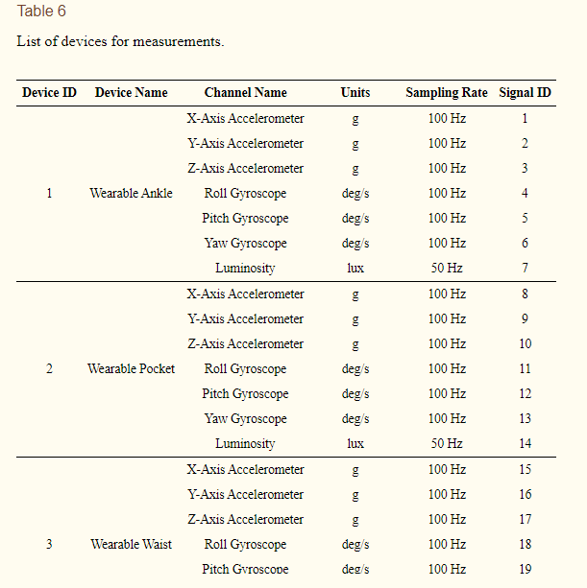

3.5. Hardware Implementation, Data Pre-Processing and Consolidation:
To gather all unrefined sensor banner, a close by system was executed. In such way, two PCs and three Raspberry Pi V3 were used as units of information. The wearable sensors and the EEG headset were related direct to the two PCs by methods for Bluetooth (three wearable sensors to one PC, and two wearable sensors notwithstanding the EEG headset to another PC). Additionally, every camera was associated with each PC through USB interface. Additionally, the infrared sensors were related in pairs to the Raspberry Pi modules. Before each subject started to play out the activities, all of the sensors and cameras started to gather the data. Later on, these devices quit gathering data much later than the conclusion of execution by the subject. All of the data were saved as CSV-records in the different units of information, containing the timestamp and the rough regards related with each sensor. It is fundamental to highlight that previously all units of information were set with a comparable time.

For association purposes, all of the data were pre-arranged. Since the contraptions ran at different investigating rates, we decided to homogenize the testing rate in the combined dataset. In that sense, we picked the camera with the least housings increased (18 fps approx.), taking as a lot of time as fundamental stamps as reference. By then, simply unrefined characteristics at these time-stamps were associated with the joined dataset. Simply infrared sensors were unreasonably moderate (4 Hz) for that examining rate, subsequently upsampling was driven using drop-testing presentation. This upsampling method involves repeating the prop up tried worth n-times (i.e., n=4 for our dataset) until the accompanying assessed regard is gotten. This upsampling data addresses 10.3% of tests related with infrared sensors. For data course of action, we recorded the start and fulfillment time-stamps of primers, and a short time later we expelled information from devices just in this between time of time. That system was possible since all contraptions recorded time-stamps locally (as of late adjusted), in this manner no data wrapping were required.

The last joined dataset contains 296,364 instances of unrefined sensor banner and pictures. These models were assembled at ∼18.4 Hz, and saved in around 812 GB of cutting edge information.

3.6. Information Storage and Publishing:

The UP-Fall Detection dataset incorporates 11 activities, with three redundancies each, performed by 17 young sound subjects with no incapacity. All activities were evaluated using 14 devices and 44 multimodal sensor signals. This dataset hopes to cover assorted human falls and essential activities for further examination, benchmarck and plan of fall revelation just as HAR systems. After pre-taking care of, general society UP-Fall Detection dataset contemplates two standard sections: (a) the consolidated dataset, and (b) the part dataset. It is extraordinary to express that the dataset has missing characteristics, and these are represented in Table7.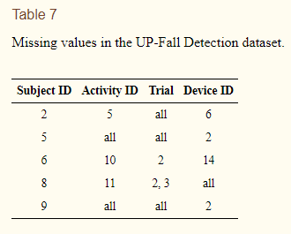

3.6.1. Consolidated Dataset:
This is the center dataset. It contains spotless and synchronized data of the exercises performed by 17 youthful solid subjects with no debilitation. Because of arranging, the dataset is isolated in information from sensors and pictures from cameras.
The information is sorted out into CSV-records (information from sensors) and ZIP-documents (pictures from cameras) as pursues. There are 17 organizers, one for each subject. Inside every organizer, there are 11 sub-envelope, one for each movement. At within these sub-organizers, there are other three sub-envelopes, one for every preliminary. In each sub-organizer, there is one CSV-document containing the pre-prepared sensor sign of that endeavor and two ZIP-documents containing the pictures recorded of that endeavor for the two cameras, one document for each camera. Figure 3 shows the association of this dataset.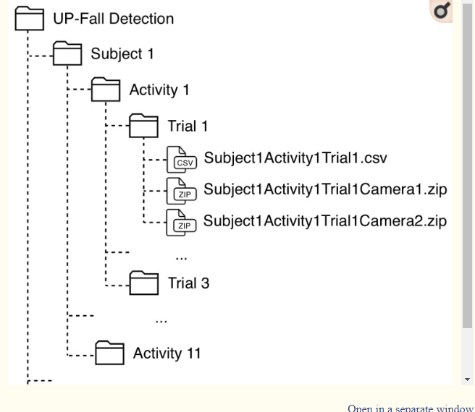
The name of each CSV-record is formed as: SubjectXActivityYTrialZ, where X is the Subject ID, Y is the Activity ID and Z is the amount of starter (1−3); and the ZIP-reports are named as: SubjectXActivityYTrialZCameraW, where W is the amount of camera (1 or 2).

Each CSV-record contains tests with: a portion with the timestamp, 42 fragments related to the sensor sign, and three areas with the amount of subject, activity and starter. Table 8 shows the relationship of this CSV-record related to the amount of portions. Feature that falls consider three states in the activity: standing, falling and laying; while simultaneously getting a thing ponders in like manner three states: standing, snatching and standing. In those cases, the characteristics in the activity section of the archives changes depending upon the state. Feature that step by step development marks were named therefore using the time-stamps, while fall starters were named physically by survey on the camera sees. Just one ace marked the models and one individual upgraded this task.
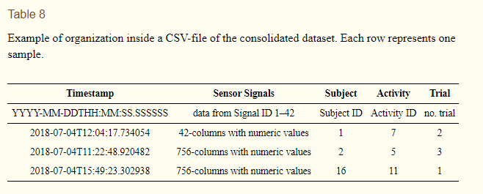

Then again, each ZIP-document contains a lot of RGB pictures in PNG position. These pictures have a document name precisely as the timestamp when they were taken, so they can be connected effectively with the information from sensors. Figure 4 shows a lot of pictures that are gathered in the dataset. It is critical to see that in spite of the fact that the dataset was gathered from falls mimicked by youthful sound subjects with no hindrance, we fused non-fall exercises and is exceptionally imbalanced as recommended so as to reproduce sporadic falls of true conditions.

3.6.2. Feature Dataset:
In most fall recognition or HAR frameworks, highlight extraction is a piece of the work process. In such manner, we chose to remove highlights from the combined dataset. For this reason, we did three diverse element datasets relying upon the window size: (a) one-second, (b) two-second and (c) three-second. All the component datasets think about half of covering. Because of designing, all these datasets are isolated in highlights from sensors and picture highlights from cameras.
The information is sorted out into CSV-records (highlights from sensors and divdided by window size) and ZIP-documents (picture highlights from cameras) similarly as in the united datasets: 17-organizers (subjects), every one with 11 sub-envelopes (exercises), with three sub-organizers (preliminaries) each. At each sub-envelope, there are three CSV-documents containing the highlights extricated for every sensor sign of that preliminary, with three window sizes, and two ZIP-records containing the picture highlights separated from the picture groupings at that endeavor for the two cameras, one record for every camera. Figure 5 shows the association of this dataset.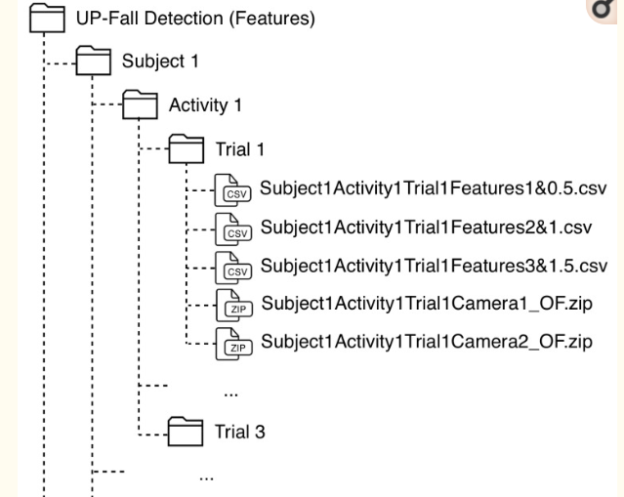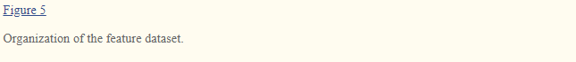
The name of each CSV-record is composed as: SubjectXActivityYTrialZFeaturesP&Q, where X is the Subject ID, Y is the Activity ID, Z is the quantity of preliminary (1–3), P is the window size (1–3 s), and Q is the size of the covering (0.5, 1 and 1.5 s). The ZIP-documents are named as: SubjectXActivityYTrialZCameraW_OF, where W is the quantity of camera (1 or 2).

Each CSV-record contains window tests, every one with: a segment with the timestamp toward the start of the window, 756 sections identified with 18 highlights separated for every one of the 42 sensor sign, and three segments with the quantity of subject, action and preliminary. Table 9 shows the association of these CSV-records. Exercises, for example, falls and getting an item were considered similarly as in the united dataset. Moreover, the worth announced at the movement segment was determined as the most incessant action an incentive over the whole window. To this end, the 18 highlights extricated are condensed in Table 10 for worldly highlights and in Table 11 for recurrence highlights.

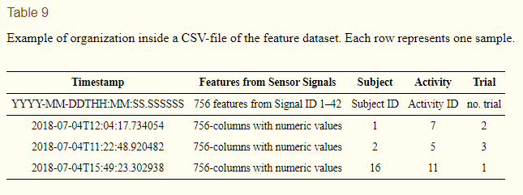

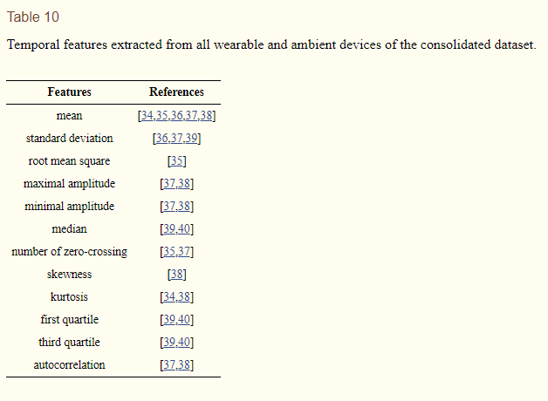
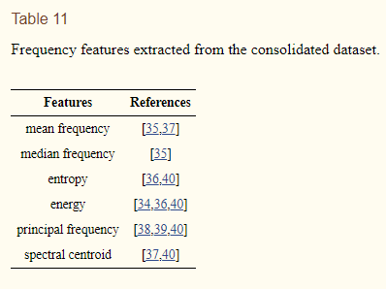
One the other hand, each ZIP-record contains a lot of packed CSV-documents that speaks to the general relocation of pixels in two continuous pictures, registered by an optical stream strategy.

4.Use Cases:
In order to show examples of usage cases in which our dataset can be important, we propose two use case circumstances: (I) modalities structure and (ii) a benchmark of AI models. For every use case, different destinations were proposed. Seven tests were proposed to achieve these targets:

• Experiment 1 (IR). Fall acknowledgment using data just from infrared sensors.

• Experiment 2 (IMU). Fall acknowledgment using data just from wearable IMUs.

• Experiment 3 (IMU+EEG). Fall acknowledgment using data from each and every wearable Imu and the EEG headset.

• Experiment 4 (IR+IMU+EEG). Fall acknowledgment using data from each and every infrared sensor, each wearable Imu and the EEG headset.

• Experiment 5 (CAM). Fall acknowledgment using only data from cameras.

• Experiment 6 (IR+CAM). Fall revelation using data from each and every infrared sensor and cameras.

• Experiment 7 (IMU+EEG+CAM). Fall revelation using data from each and every wearable Imu, EEG headset and cameras.

The above mixes are not extensive. Assessments with all sort of mixes using only a couple of sensors with different regions or possibly modalities can be arranged depending of the inspiration driving the preliminaries. Remarkable and new figurings can in like manner be used.

5.Existing systems:
Apple watch 4 working
An Apple Watch Series 4 can recognize in the event that you've fallen and consequently call 911 to get your wounds tended to. Or on the other hand get you captured, contingent upon the conditions.
That is the admonition of protection guard dogs, who bring up that 911 calls welcome in something other than crisis medicinal work force.
At the point when the most recent Apple Watch identifies a "huge, hard fall," you get a tap on the wrist, a caution sounds, and an alarm is shown. You can tell your Watch you fell yet you're OK, or you can disclose to it you didn't fall by any means.
In the event that you don't do anything, your Watch will consequently call 911 and tell your crisis contact.

How Apple Watch fall identification can turn out badly
Elizabeth Joh, a law teacher at the University of California at Davis, called attention to on Twitter: "Consider: your watch (inadvertently) alarms the police to keep an eye on you: fourth Amend. network caretaking special case implies they can enter your home w/o a warrant. Plain see implies they may hold onto stash/proof of a wrongdoing. Decent work, folks."

5.1. Whats new with our model:
Apple watch working with gyrator and accelemeter just yet in our model it is mapped with senor in addition to camera vision(2 edges).
Few out of every odd one considers the to be as the best spot for example we made our model to screen falls by utilizing pictures and sensors.

7.Algorithm:
Used Algorithm:

Revisiting ResNet
As indicated by the all inclusive guess hypothesis, given enough limit, we realize that a feedforward coordinate with a solitary layer is adequate to speak to any capacity. Nonetheless, the layer may be gigantic and the system is inclined to overfitting the information. Hence, there is a typical pattern in the exploration network that our system engineering needs to go further.
Since AlexNet, the best in class CNN engineering is going further and more profound. While AlexNet had just 5 convolutional layers, the VGG system and GoogleNet (additionally codenamed Inception_v1) had 19 and 22 layers separately.
Nonetheless, expanding system profundity doesn't work by basically stacking layers together. Profound systems are difficult to prepare in view of the famous evaporating angle issue — as the inclination is back-proliferated to prior layers, rehashed duplication may make the slope infinitively little. Subsequently, as the system goes further, its presentation gets soaked or even starts debasing quickly.
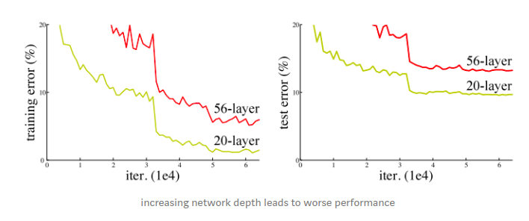

Before ResNet, there had been a few different ways to bargain the evaporating slope issue, for example, includes an assistant misfortune in a center layer as additional supervision, yet none appeared to truly handle the issue for the last time.
The center thought of ResNet is presenting a purported "personality alternate way association" that avoids at least one layers, as appeared in the accompanying figure:
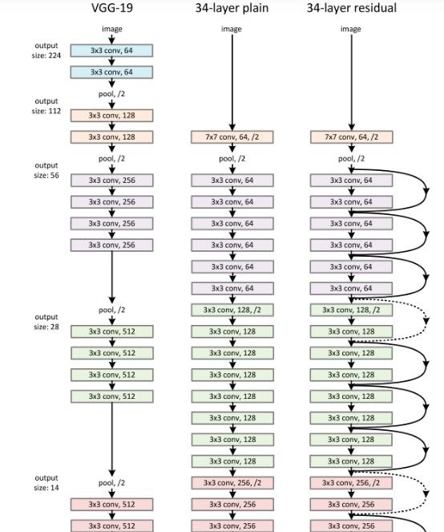
The middle idea of ResNet is displaying an implied "character exchange way affiliation" that maintains a strategic distance from in any event one layers, as showed up in the going with figure:The creators of contend that stacking layers shouldn't corrupt the system execution, since we could just stack personality mappings (layer that doesn't do anything) upon the present system, and the subsequent design would play out the equivalent.

This demonstrates the more profound model ought not create a preparation mistake higher than its shallower partners. They conjecture that giving the stacked layers a chance to fit a leftover mapping is simpler than letting them straightforwardly fit the ideal underlaying mapping. What's more, the leftover square above unequivocally enables it to do decisively that.

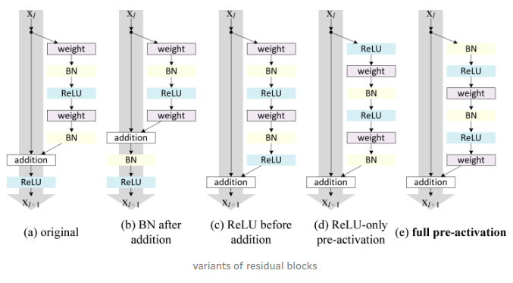
Following this instinct, the creators of refined the lingering square and proposed a ,where the inclinations can course through the alternate route associations with some other prior layer unimpededly. Truth be told, utilizing the first leftover square in, preparing a 1202-layer ResNet brought about more terrible execution than its 110-layer partner.

The creators of showed with tests that they would now be able to prepare a 1001-layer profound ResNet to beat its shallower partners. In light of its convincing outcomes, ResNet immediately got one of the most mainstream models in different PC vision

Ongoing Variants and Interpretations of ResNet

As ResNet acquires and greater prevalence in the examination network, its design is
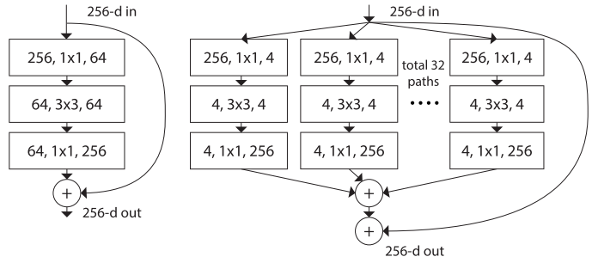

Densely Connected CNN

Huang et al. proposed a novel engineering called DenseNet that further adventures the impacts of easy route associations — it interfaces all layers legitimately with one another. In this novel engineering, the contribution of each layer comprises of the element maps of all prior layer, and its yield is passed to each ensuing layer. The component maps are collected with profundity connection.

Other than handling the disappearing slopes issue, the creators of contend that this design additionally energizes include reuse, making the system profoundly parameter-productive. One basic understanding of this is, in ,the yield of the personality mapping was added to the following square, which may hinder data stream if the element maps of two layers have altogether different circulations. Along these lines, connecting highlight maps can save them all and increment the change of the yields, empowering highlight reuse.

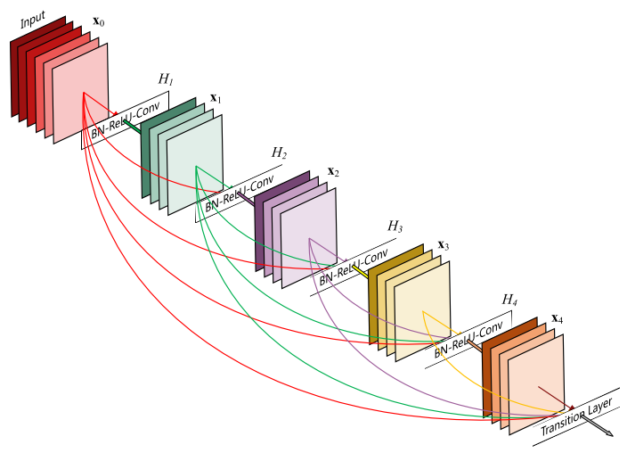

Huang et al. proposed a novel engineering called DenseNet that further adventures the impacts of easy route associations — it interfaces all layers legitimately with one another. In this novel engineering, the contribution of each layer comprises of the element maps of all prior layer, and its yield is passed to each ensuing layer. The component maps are collected with profundity connection.

Other than handling the disappearing slopes issue, the creators of contend that this design additionally energizes include reuse, making the system profoundly parameter-productive. One basic understanding of this is, in ,the yield of the personality mapping was added to the following square, which may hinder data stream if the element maps of two layers have altogether different circulations. Along these lines, connecting highlight maps can save them all and increment the change of the yields, empowering highlight reuse.

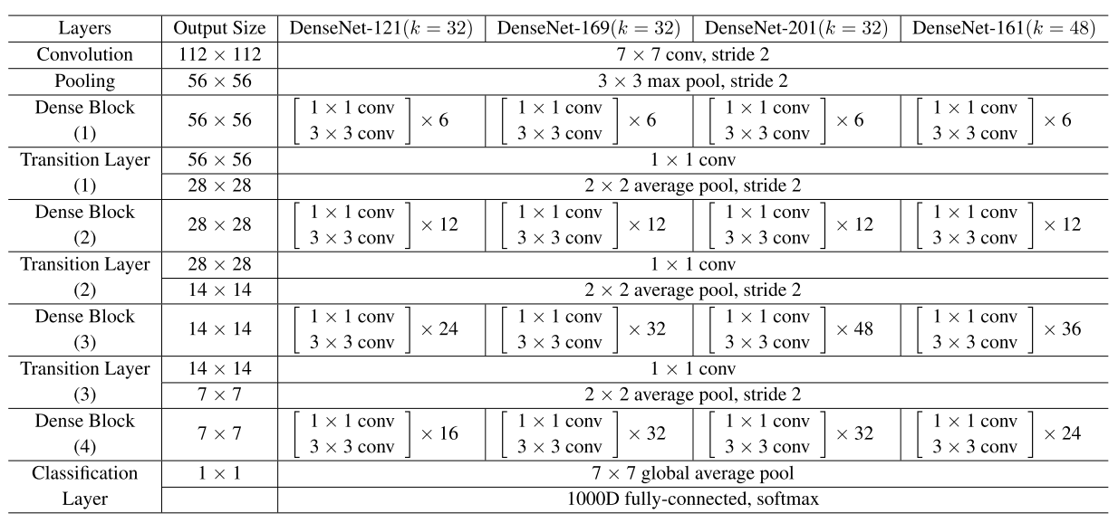
Following this worldview, we realize that the l_thlayer will have k * (l-1) + k_0 input include maps, where k_0 is the quantity of directs in the information picture. The creators utilized a hyper-parameter called development rate (k) to keep the system from developing excessively wide, they likewise utilized a 1x1 convolutional bottleneck layer to diminish the quantity of highlight maps before the costly 3x3 convolution. The general archiecture is appeared in the underneath table:

Deep Network with Stochastic Depth
Although ResNet has proven powerful in many applications, one major drawback is that deeper network usually requires weeks for training, making it practically infeasible in real-world applications. To tackle this issue, Huang et al. introduced a counter-intuitive method of randomly dropping layers during training, and using the full network in testing.
The authors used the residual block as their network’s building block, therefore, during training, when a particular residual block is enable, its input flows through both the identity shortcut and the weight layers, otherwise the input only flows only through the identity shortcut. In training time, each layer has a “survival probability” and is randomly dropped. In testing time, all blocks are kept active and re-calibrated according to its survival probability during training.
Formally, let H_l be the output of the l_th residual block, f_l be the mapping defined by the l_th block’s weighted mapping, b_l be a Bernoulli random variable that be only 1 or 0 (indicating whether a block is active), during training:

When b_l =1, this block becomes a normal residual block, and when b_l = 0, the above formula becomes:

Since we know thatH_(l-1) is the output of a ReLU, which is already non-negative, the above equation reduces to a identity layer that only passes the input through to the next layer:

Let p_l be the survival probability of layer l during training, during test time, we have:
The creators applied a straight rot rule to the endurance likelihood of each layer, they contend that since prior layers remove low-level highlights that will be utilized by later ones, they ought not be dropped too much of the time, the subsequent standard along these lines becomes:
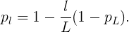

Where L denotes the all out number of squares, thus p_L is the endurance likelihood of the last leftover square and is fixed to 0.5 all through tests. Additionally note that in this setting, the information is treated as the principal layer (l = 0) and subsequently never dropped.

8.Problem Analysis:
8.1. Feasibility Analysis: As in this section we assess the strengths and weakness of the proposed project and are as follows:
The model can understand and react to specific inputs from sensors and camera vison. The model is developed based on computer vision process and deep learning. It will detect multiple human falls in order to save lives.

The project is feasible from both development and deployment point of view as we have used google colab for development which itself is an open-source tool and further uses APIs from google which are also free. And data is provided by HAR-UP multimodal fall detection 2019 challenge. Data is directly loaded from google drive to colab.

8.2. Project Plan:
Step1:
Data acquisition
Step2:
Data cleaning
Step 3:Splitting data into training and testing
Step 4:
Preprocessing
Step 5:
Model development
Step 6:Model prediction

9.Software Requirement Analysis:
Python Libraries:
- Pandas
- Numpy
- Seaborn
- Torchvision
- OS
- Zipfile
- Matplotlib
- Fastprogress
- Shutil
- Torch
- Fastai

10.)Data Flow Diagrams

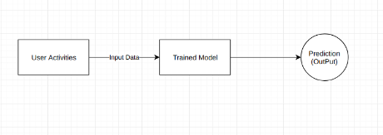

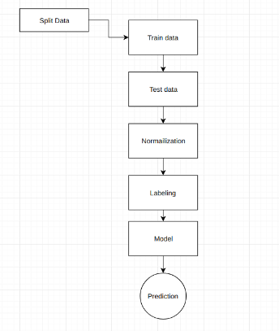

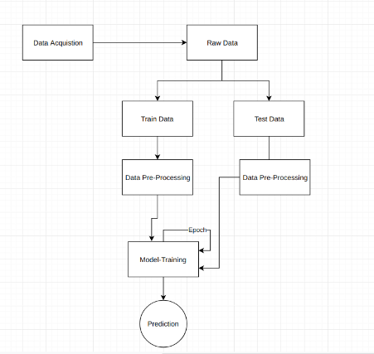

11.Testing
11.1.Functional Testing

In functional testing we need check every part are working true to form or not all that it is called as segment testing

Utilitarian testing is to trying the usefulness of the product applications under test. Fundamentally, it is to check the essential usefulness referenced in the utilitarian particular record additionally check whether programming application is meeting the client desires. We can likewise say that checking the conduct of the product application against test determination.

This kind of testing is obligatory and independent of what sort of utilization this ought to be worked out.

What all need to check in Functional Testing

1. Is program is working as it ought to do?

2. Is program isn't working as it ought not do?

3. Is program isn't doing as it not proposed to do?

11.2. Structural Testing :

The basic testing is the trying of the structure of the framework or part auxiliary testing is frequently alluded to as white box or glass box or clear box testing in light of the fact that in basic testing we are keen on what's going on inside the framework/application. In basic testing the analyzers are required to have the information on the inward executions of the code. Here the analyzers require information on how the product is actualized, how it works. During auxiliary testing the analyzer is focusing on how the product does it for instance, a basic procedure needs to realize how circles in the product are functioning. Distinctive experiments might be inferred to practice the cut once, twice, and commonly. This might be done paying little respect to the usefulness of the product. Basic testing can be utilized at all levels of testing. Engineers utilize basic testing in segment testing and part joining testing, particularly where there is great device support for code inclusion. Auxiliary testing is additionally utilized in framework and acknowledgment testing, yet the structures are unique.

12.Source Code

1)##Importing libraries
import torchvision.models as models
import os
import zipfile
import cv2
import matplotlib.pyplot as plt
import pandas as pd
from fastprogress import progress_bar
%matplotlib inline

2)## giving the access to the google drive
from google.colab import drive
drive.mount('/content/drive')

3)##loading the image data to google colab (subject 1,2,3,10) from google drive
%%bash
for i in {1,3,4,10}; do \
cp -r /content/drive/My\ Drive/unzip/Camera2_training_competition/Subject$i ./
Done

4)##loading the dataset to google colab from google drive
!cp /content/drive/My\ Drive/unzip/CompleteDataSet_training_competition.csv ./

5)##loading the dataset to variable
sensor_data=pd.read_csv("/content/CompleteDataSet_training_competition.csv")

6)##assessing sensor data
assert sensor_data.TimeStamps.nunique()==sensor_data.shape[0]
Sensor_data.shape

7)###directory of data
!mkdir data
!mkdir data/train
!mkdir data/test

8)##Unzip the data
def unzip(subject,activity,trail,is_train_subject):
extract_dir=f"data/train/"+activity
if not is_train_subject:
extract_dir=f"data/test/"+activity
if not os.path.exists(extract_dir):
os.mkdir(extract_dir)
with zipfile.ZipFile(f"{subject}/{activity}/{trail}","r") as zip_ref:
zip_ref.extractall(extract_dir)

9)##Mentioning the file paths
subject_file_paths=['Subject1','Subject3','Subject4','Subject10']
subject_mode={'Subject1':True,'Subject3':True,'Subject4':True,'Subject10':False}#True if subject needs to be in the training

10)##importing shutil library
import shutil
# shutil.rmtree("data")

11)##loop to access the files
%%time
for subject in progress_bar(subject_file_paths):
for activity in progress_bar(os.listdir(subject)):
for trail in os.listdir(f"{subject}/{activity}"):unzip(subject,activity,trail,subject_mode[subject])

12)##funtion to clean directories of png files
def clean_directories__get_png_files(path):
image_names=[]
for activity in progress_bar(os.listdir(path)):
for file_ in os.listdir(f"{path}/{activity}"):
fp=f"{path}/{activity}/{file_}"
if os.path.isdir(fp):
print(f"deleting {fp}")
shutil.rmtree(fp)
else: image_names.append(file_)
return image_names

13)##cleaning train data
train_image_names=clean_directories__get_png_files("data/train")

14)##cleaning test data
test_image_names=clean_directories__get_png_files("data/test")

15)##IMporting Libraries
from __future__ import print_function, division
import os
import torch
import pandas as pd
from skimage import io, transform
import numpy as np
import matplotlib.pyplot as plt
from torch.utils.data import Dataset, DataLoader
from torchvision import transforms, utils

16)##data slicing
sensor_data_sliced=sensor_data[sensor_data.Subject.isin([1,3,4,10])]

17)##Mention the required coloumns
to_keep_columns=['TimeStamps', 'AnkleAccelerometer x-axis', 'AnkleAccelerometer y-axis',
'AnkleAccelerometer z-axis', 'AnkleAngularVelocity x-axis ',
'AnkleAngularVelocity y-axis ', 'AnkleAngularVelocity z-axis ',
'RightPocketAccelerometer x-axis ',
'RightPocketAccelerometer y-axis ', 'RightPocketAccelerometer z-axis ',
'RightPocketAngularVelocity x-axis',
'RightPocketAngularVelocity y-axis',
'RightPocketAngularVelocity z-axis',
'BeltAccelerometer x-axis',
'BeltAccelerometer y-axis', 'BeltAccelerometer z-axis',
'BeltAngularVelocity x-axis', 'BeltAngularVelocity y-axis',
'BeltAngularVelocity z-axis',
'NeckAccelerometer x-axis', 'NeckAccelerometer y-axis',
'NeckAccelerometer z-axis', 'NeckAngularVelocity x-axis',
'NeckAngularVelocity y-axis', 'NeckAngularVelocity z-axis',
'WristAccelerometer x-axis',
'WristAccelerometer y-axis', 'WristAccelerometer z-axis',
'WristAngularVelocity x-axis', 'WristAngularVelocity y-axis',
'WristAngularVelocity z-axis',"Tag",'Subject']

18)##required coloumns
features=to_keep_columns[1:-3]

19)##required coloumns
sliced_csv=sensor_data_sliced[to_keep_columns]

20)##spliting train and test data
train_csv=sliced_csv[sliced_csv.Subject.isin([1,3,4])]
test_csv=sliced_csv[sliced_csv.Subject==10]

21)##Function forFMapping and dropping missing data and values
def map_and_drop_missing_data(image_files,csv):
print("Images from cam",len(image_files))
print("sensor data",csv.shape)
image_ids=[val[:-4] for val in image_files]
csv_ids=csv.TimeStamps.values
image_compatible_csv_ids=[val.replace(':','_') for val in csv_ids]
to_conider_image_files=set(image_ids).intersection(image_compatible_csv_ids)
remapped_csv_ids=[val.replace('_',':') for val in image_compatible_csv_ids]
print("final images",len(remapped_csv_ids))
return csv[csv.TimeStamps.isin(remapped_csv_ids)]

22)##Final train data after mapping and dropping missing values
final_train_csv=map_and_drop_missing_data(train_image_names,train_csv)

Output:
Images from cam 53594
sensor data (53592, 33)
final images 53592

23)##Final test data after mapping and dropping missing values
final_test_csv=map_and_drop_missing_data(test_image_names,test_csv)

Output:
Images from cam 17601
sensor data (17601, 33)
final images 17601

24)##Bar plot for subjects counts in train data
final_train_csv.Subject.value_counts().plot(kind='bar')

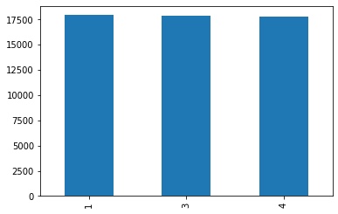

25)##Bar plot for tags in train data
final_train_csv.Tag.value_counts().plot(kind='bar')

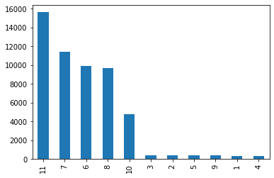

26)##Bar plot for subjects counts in test data
final_test_csv.Subject.value_counts().plot(kind='bar')

27)##Bar plot for tag counts in test data
final_test_csv.Tag.value_counts().plot(kind='bar')

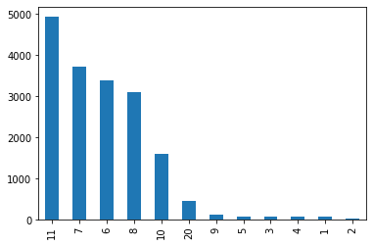

28)##Function to map images with activities and return path
##Another function to rearrange the tag and timestamps and save as an id.
def map_image__csv(ts,activity):
ts=ts.replace(':','_')
image_path=f"Activity{activity}/{ts}.png"
return image_path
def rearrange_dataframe(df):
df["id"]=df.apply(lambda x:map_image__csv(x['TimeStamps'], x['Tag']),axis=1)
return df

29)##Rearrange train and test data using function rearrange_dataframe
final_train_csv=rearrange_dataframe(final_train_csv)
final_test_csv=rearrange_dataframe(final_test_csv)

30)##Importing libraries and final test and train data
final_test_csv["Tag"]=final_test_csv["Tag"]-1
final_train_csv["Tag"]=final_train_csv["Tag"]-1
from fastai.vision import *
import torch.nn as nn
import torch.nn.functional as F
import torch

31)##resnet model declaration
restnet=models.resnet34(pretrained=True, progress=True)
restnet_updated = nn.Sequential(*list(restnet.children())[:-1])

33)##declaring a model variable
r=net(torch.randn(size=(16,3,224,224)).to(device),torch.randn(size=(16,29)).to(device))

34)##Functions to read dataset
class CustomDataset(Dataset):
def __init__(self, csv_file, root_dir,features=features):
self.csv_file, self.root_dir,self.features= csv_file, root_dir,features
self.c = 11 # binary label
self.classes=[f'Tag{i+1}' for i in range(10)]
self.y=[f'Tag{i+1}' for i in range(10)]
def __len__(self):
return len(self.csv_file)
def __getitem__(self, i):
img_name = os.path.join(self.root_dir,
self.csv_file["id"].iloc[i])
image = cv2.imread(img_name)
image=cv2.resize(image,(224,224))
image=image.reshape(3,224,224)
image=image/255
sensors_data_array = np.array(self.csv_file[self.features].iloc[i]).astype(np.float32)

return [image,sensors_data_array], self.csv_file["Tag"].iloc[i]

35)##train and validation set splitted from final train set
train_ds, valid_ds = CustomDataset(final_train_csv,"/content/data/train"), CustomDataset(final_test_csv,"/content/data/test")

-`Using Fast AI Training Loop`

38)##Creating data into batch sizes
data = DataBunch.create(train_ds, valid_ds, bs=32, num_workers=1)
l=data.one_batch()

39)##declaration of iteration
t=next(iter(train_dl))

40)## determining the every perticular image to which activity it belong
class LsfmNet(nn.Module):
def __init__(self,init_net,no_sensor_features,classes):
super(LsfmNet, self).__init__()
self.restnet = init_net
self.fc1 = nn.Linear(512, 120)
self.fc2 = nn.Linear(120+no_sensor_features, 60)
self.fc3 = nn.Linear(60, classes)

def forward(self, image,data):
image=image.type(torch.float32)
rest_out = self.restnet(image)
x1=self.fc1(rest_out.squeeze())
if len(x1.size())==1:x1=torch.unsqueeze(x1, dim=0)
x = torch.cat((x1, data), dim=1)
x = F.relu(self.fc2(x))
x = self.fc3(x)
return F.softmax(x)

41## updating LsfmNet to learn
lsfmnet = LsfmNet(restnet_updated,29,11)

/usr/local/lib/python3.6/dist-packages/ipykernel_launcher.py:17: UserWarning: Implicit dimension choice for softmax has been deprecated. Change the call to include dim=X as an argument.
LR Finder is complete, type {learner_name}.recorder.plot() to see the graph

42##declaring the image
device="cuda:0"

43##predicting the relust
learn = Learner(data, lsfmnet, metrics=error_rate,loss_func = nn.CrossEntropyLoss())

45
learn.recorder.plot()
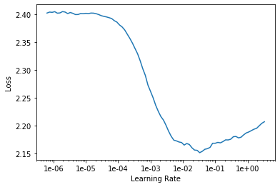

46##learning the model with epoch=4 by giving the limit max_lr=3*1e-3
learn.fit_one_cycle(4,max_lr=3*1e-3)

epoch | train_loss | valid_loss | accuracy | time
0 | 1.649628 | 1.880770 | 0.661708 | 24:54
1 | 1.599291 | 1.783487 | 0.759130 | 24:54
2 | 1.607632 | 1.750645 | 0.791973 | 25:01
3 | 1.588743 | 1.761409 | 0.781064 | 25:14

accuracy=78.1064
Due to the epoch =4
To increase the accuracy we have increase the epoch cycle

47
interp = ClassificationInterpretation.from_learner(learn)

48
losses,idxs = interp.top_losses()

49
len(data.valid_ds)==len(losses)==len(idxs)

50
len(idxs),len(losses)

51
class Dummy:
def __init__(self):
self.classes=[f'Tag{i+1}' for i in range(10)]
y=Dummy()
CustomDataset.y=y

52
interp.plot_confusion_matrix(figsize=(12,12), dpi=60)

53
learn.unfreeze()
learn.lr_find()

54
learn.recorder.plot()

55
learn.fit_one_cycle(2,max_lr=3e-3)

56
slice(3e-3,1e-3/2)

57
interp = ClassificationInterpretation.from_learner(learn)

58
losses,idxs = interp.top_losses()
59
len(data.valid_ds)==len(losses)==len(idxs)

60
# Wrong confusion matrix, need to fix
interp.plot_confusion_matrix(figsize=(12,12), dpi=60)

13.Project Legacy
13.1Current Status of the Project

SO.NO | Project | Status
1. | Planning | Completed
2. | Data gathering | Completed
3. | Design | Completed
4. | Source code | Completed
5. | Testing | Completed
6. | Working | Completed

14.Final Result :
epoch | train_loss | valid_loss | accuracy | time
0 | 1.649628 | 1.880770 | 0.661708 | 24:54
1 | 1.599291 | 1.783487 | 0.759130 | 24:54
2 | 1.607632 | 1.750645 | 0.791973 | 25:01
3 | 1.588743 | 1.761409 | 0.781064 | 25:14

accuracy=78.1064
Due to the epoch =4
To increase the accuracy we have increase the epoch cycle

